**WEEK 2: EXERCISE 2**Database System and Cloud (BERR2243)

*Provided by:*

|  |  |
| --- | --- |
| Group Member | Id No. |
| Ahmad Muhaimin Azeem Bin Adri Wafik | B122310496, 2 BERR S2 |
| Syafiq Iman Bin Suhaimi | B122310218, 2 BERR S2 |

JSON QUESTIONS

1. Explain what is CRUD operations and how it is relates to the mongo functions in the exercise.

**CRUD operations is the basic operations performed on data stored in databases. CRUD stands for Create, Read, Update and Delete.**

1. Identify all the mongo operators used in the exercise, then explain the usage for each.
2. **$gte (greater than or equal operator)**

**To match value greater than or equal to a specified value**

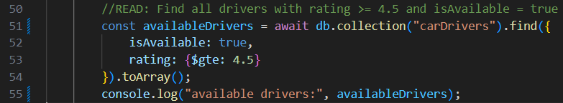

1. **$inc (increment or decrement operator)**

**To increment or decrement the value of numeric field by a specified amount. If positive value is provided, the operator performs increment. If negative value is provided, the operator performs decrement.**

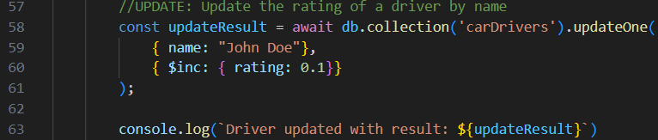

1. Replace the mongo functions in Task 5 to updateMany instead of updateOne,

compare the difference based on the result in console and the mongo compass.

**updateOne() method**

***Code:***

**

**

***Output:***

***VS Code***



***MongoDB***

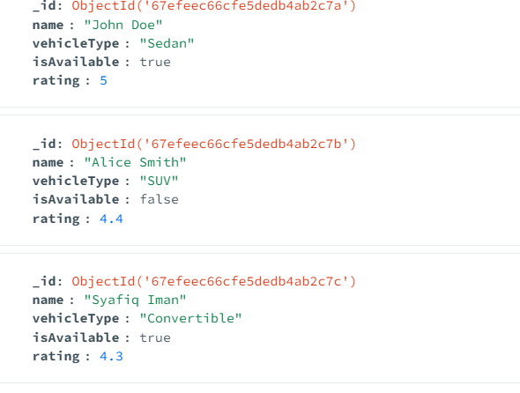

Updated the rating when first isAvailable: true only was found

**updateMany() method**

***Code:***

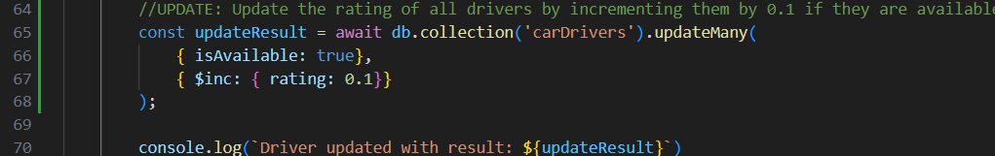

***Output:***

***VS Code:***



**MongoDB:**

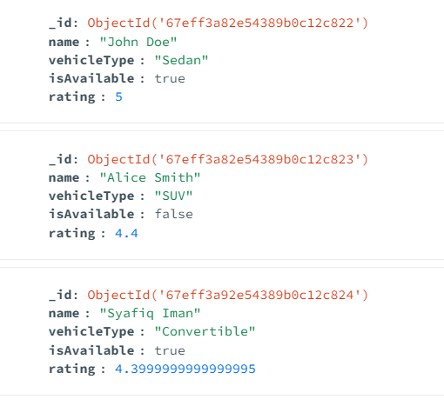

Updated the rating for **all** isAvailable: true were found

1. Replace the mongo functions in Task 6 to deleteMany instead of deleteOne,

compare the difference based on the result in console and the mongo compass.

**deleteOne() method**

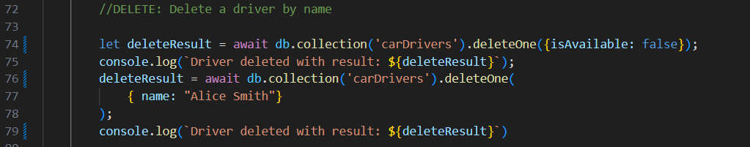   
 ***Code:***

***Output:***

***VS Code***



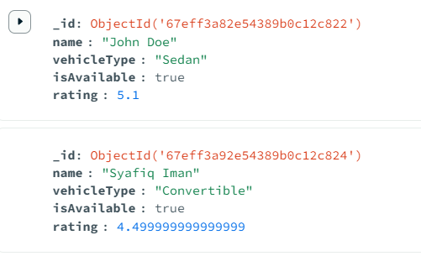***MongoDB***

Object name: “Alice Smith” is deleted

**deleteMany() method**

***Code:***

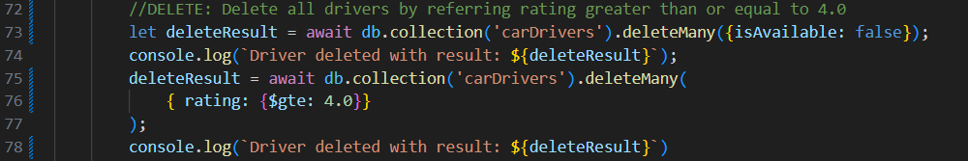

***Output:***

***VS Code***



***MongoDB***



No data at all. All data deleted.